Camouflage, colour and song

All birds of different species have different coloured feathers. Bird song also varies from species to species. Brightly coloured birds tend to be males and they use their coloured feathers for display and to attract a mate. Most dull birds tend to be female, they are camouflaged. Birds sing to attract a mate and to defend their territories.

TICK the box if the sentence is TRUE. Put a CROSS in the box if the sentence is FALSE

Tick/Cross
Some male birds are brightly coloured to attract a mate ◻
Male curlews are brightly coloured ◻
Some female birds are camouflaged to hide on their nests ◻
All female birds have bright colours to attract a mate ◻
Most chicks have mottled feathers ◻
Most chicks are brightly coloured ◻

From the selection below, fill in the missing words. Use each word only ONCE

- Birds sing to mark their ________________ and to ________________ a mate
- Female birds often have duller coloured ___________________ than male birds
- Female birds usually have better ________________________
- Male birds have brightly coloured feathers for ______________
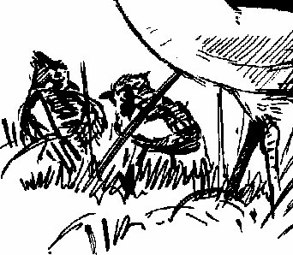
- Brightly coloured feathers help male birds to attract a ________
feathers territory attract
mate display camouflage

Discussion Points
What does camouflage help to protect some birds from?

