Key Species Fact Sheet

The three key bird species in the Forest of Bowland are lapwing, curlew and hen harrier.
These birds are different in many ways. Can you design a fact sheet for each bird?
Try to include the following information in your fact sheet.
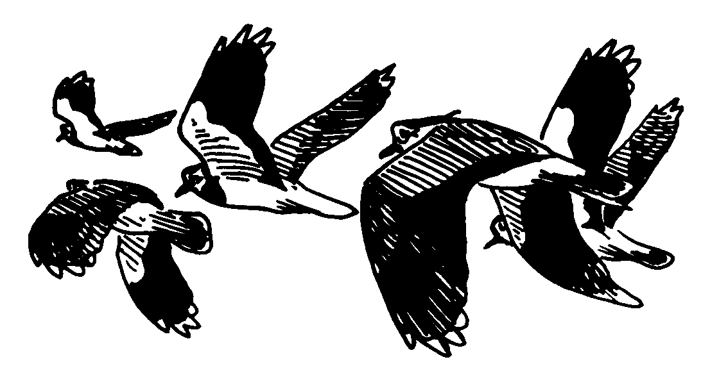
- Pictures
- Description of colours and markings
- Size
- Behaviour
- Flight
- Voice
- Habitat
- Population
- Food
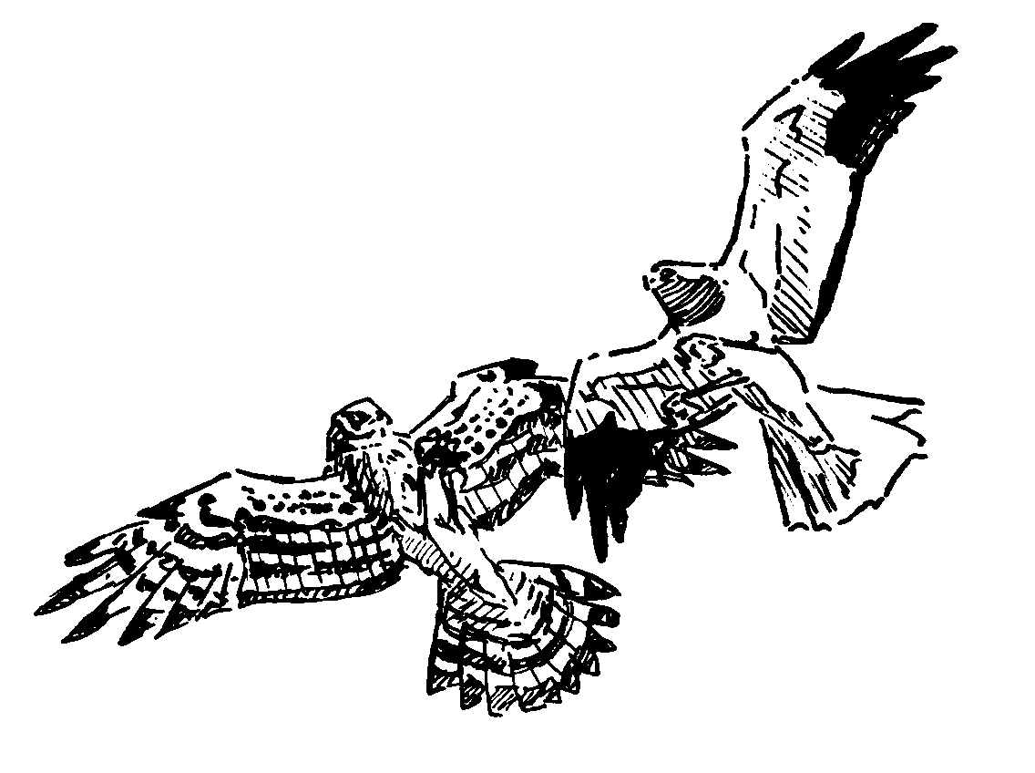
- Nesting place and time
- Number and colour of eggs
- How many broods
- Incubation time
- Description of the young
- How long to becoming a fledging
- Migration
- Distribution map

Here are a few books and websites that might help but there are many more
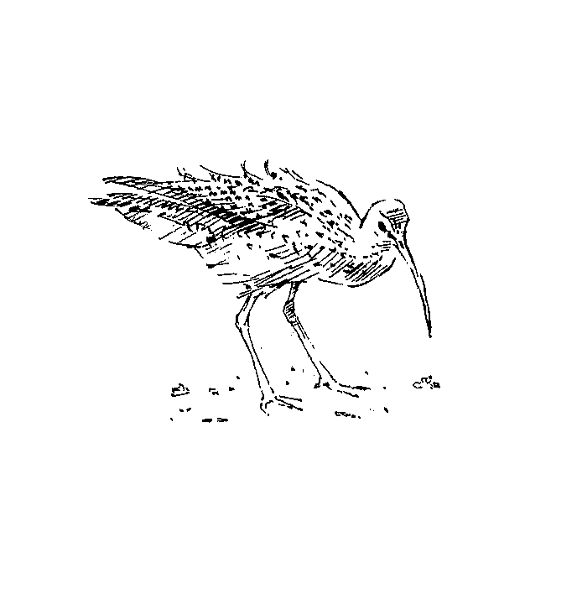
- www.rspb.org.uk
- www.uk-birds.org.uk
- http://en.wikipedia.org/wiki/Curlew
- The RSPB Guide to British Birds
- The RSPB Handbook of British Birds
- Collins Complete Guide to British Birds
- Collins Bird Guide

