Haiku Poetry

In real Japanese haiku poetry, the poet tries to capture the essence of a scene or moment in 17 syllables. The style forces you to think about the subject in a very different way and the result can be quite startling in its beauty and simplicity. Although it is a high art form in Japan, using the following formula can capture some of the beauty.

Activity
Everyone will need a pencil and paper
Sit the group outside, facing outwards. Ask each of the group to find something nearby that gets their attention. Anything goes but preferably a natural object.

The first line of their haiku is one word for their chosen object, its name.
The second line is two words that describe the object.
The third is three words that describe how they feel about the object.
The fourth and final line is another one or two words that name the object.

Ask them to turn back towards the centre of the circle, shuffle the haiku and get them to read out someone else’s work.

Repeat using pictures, photos, etc as an inspirational source.

Here are a few examples to start you thinking
Bird
Small, pretty
Interesting to watch
Blue tit
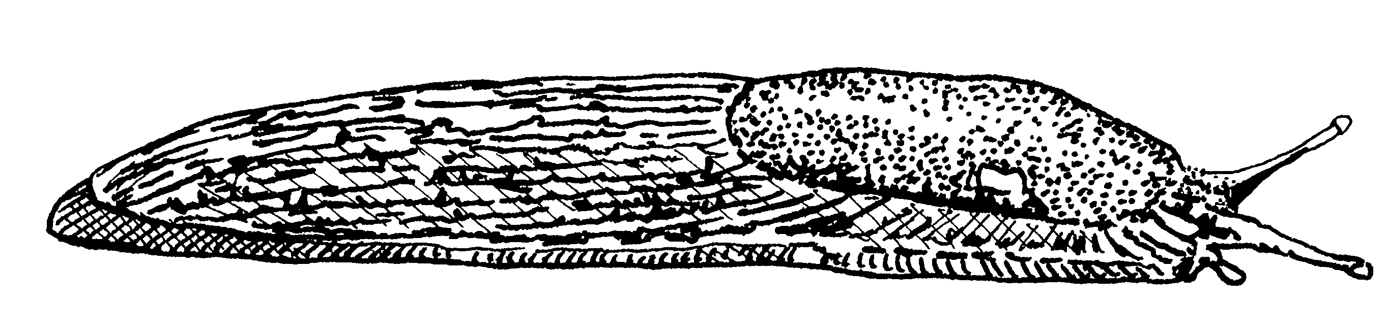

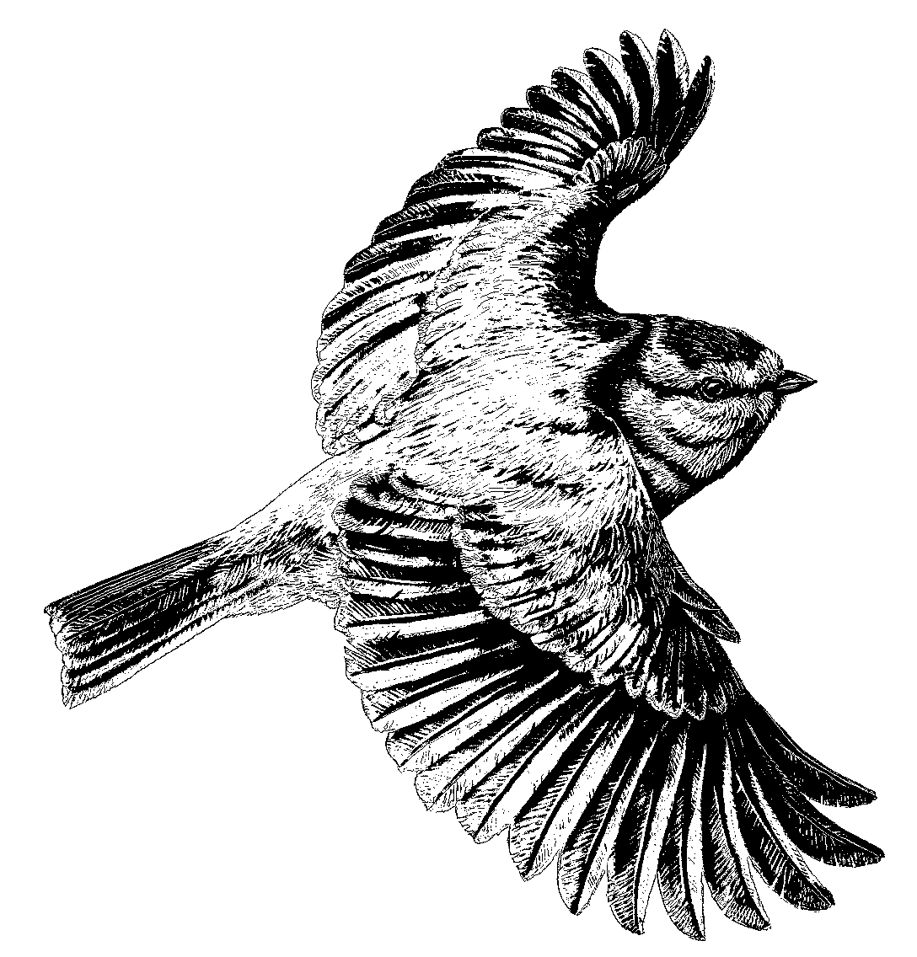
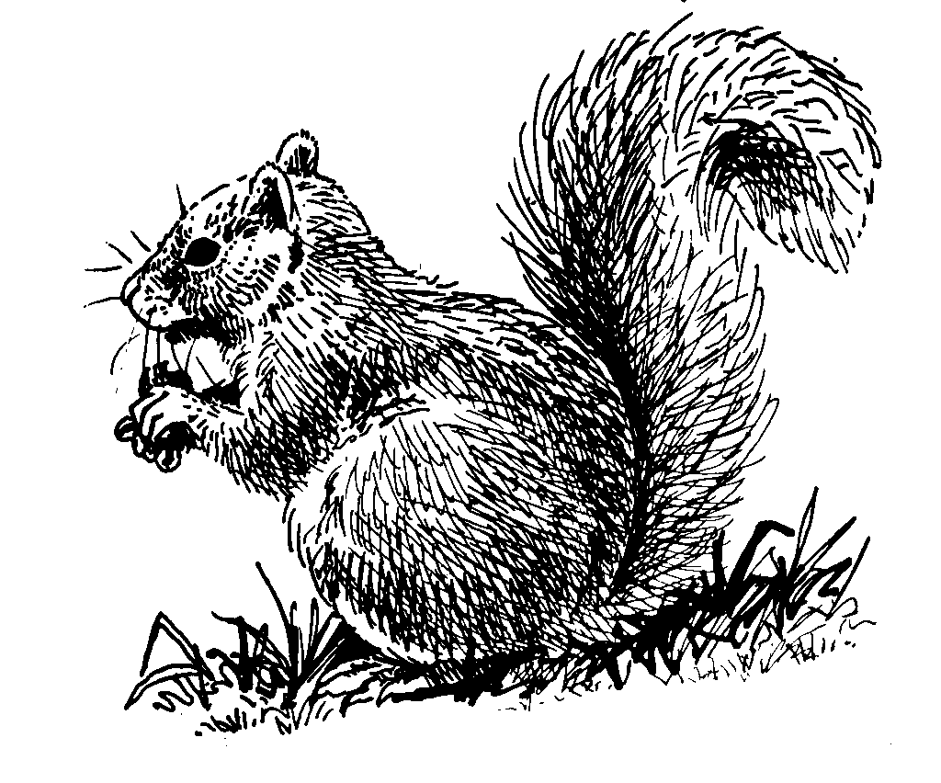
Slug
Slimy, glistening
Fascinating, ugh! repellent
Slimeball
Squirrel

Grey, cheeky
Entertaining, fast, dangerous
Rodent

