Adaptation – feet

Different birds have different legs and feet. This means they are adapted to live and feed in different places (habitats).

Why do the following birds have the feet and legs described below?
Draw a line to link each correct pair of statements:

Hen harriers have strong talons

Woodpeckers have four strong toes,
two pointing forwards and
two pointing backwards

Curlews and lapwings have long legs

Robins have small claws

Ducks have webbed feet

Herons have very long legs

Coots have lobed toes

They wade in deep water

They don’t sink in the mud and have help to swim

They hold on to branches

They catch their food with their feet

They wade in marshy ground

They climb trees

They swim well

Which birds do these legs belong to? Write the name by the picture.
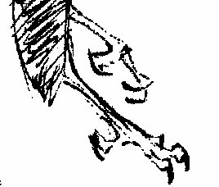
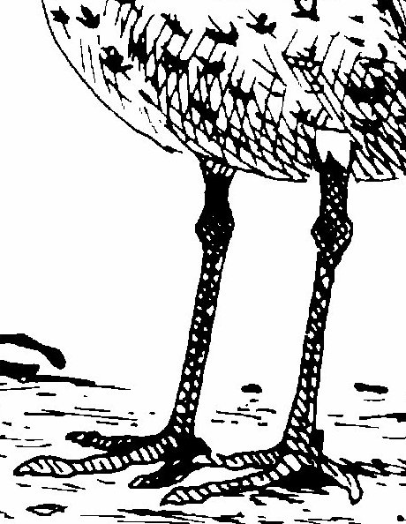
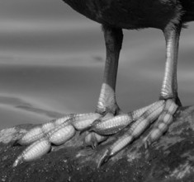
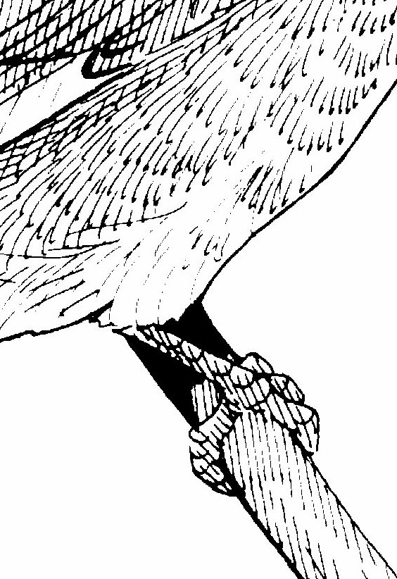

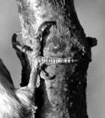

Discussion point
How are birds adapted to live in different habitats?

