Adaptation – beaks

Birds feed on different foods and because of this they have differently shaped beaks.
This means that their beaks are adapted for the type of food they eat. Because of birds’ adaptations to certain foods, they feed in certain habitats.

Complete the sentences by matching the food type and the feeding habitat from the two lists below.
Write the correct number or letter on the lines.

Food type Feeding habitat
Ducks have wide flat beaks, which act like a sieve _____________ ____________
Herons have long sharp beaks ______________ ____________
Curlews have long down-curved beaks ______________ ____________
Greenfinches have short thick beaks ______________ ____________
Swallows have very wide mouths ______________ ____________
Lapwings have shortish straight beaks ______________ ____________
Blackbirds have ‘all-purpose’ beaks ____________ ____________

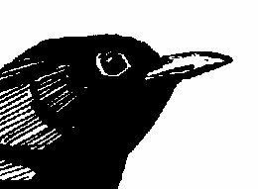
Hen harriers have sharp, hooked beaks ____________ ____________

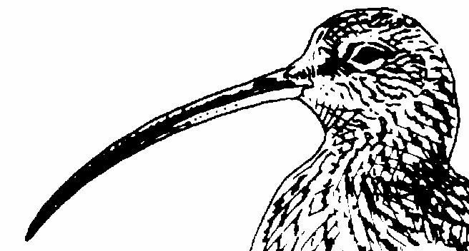
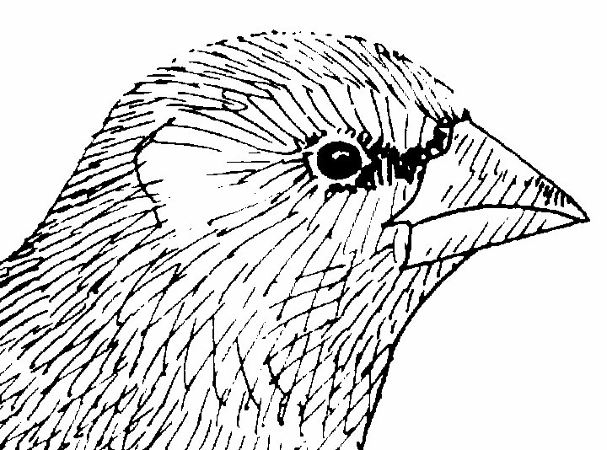

Food type
- Pond weed and small pond creatures
- Small birds and mammals
- Fish and eels
- Worms and shellfish
- Worms and insects
- Flying insects
- Seeds
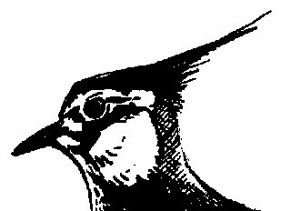
- Worms, seeds and berries
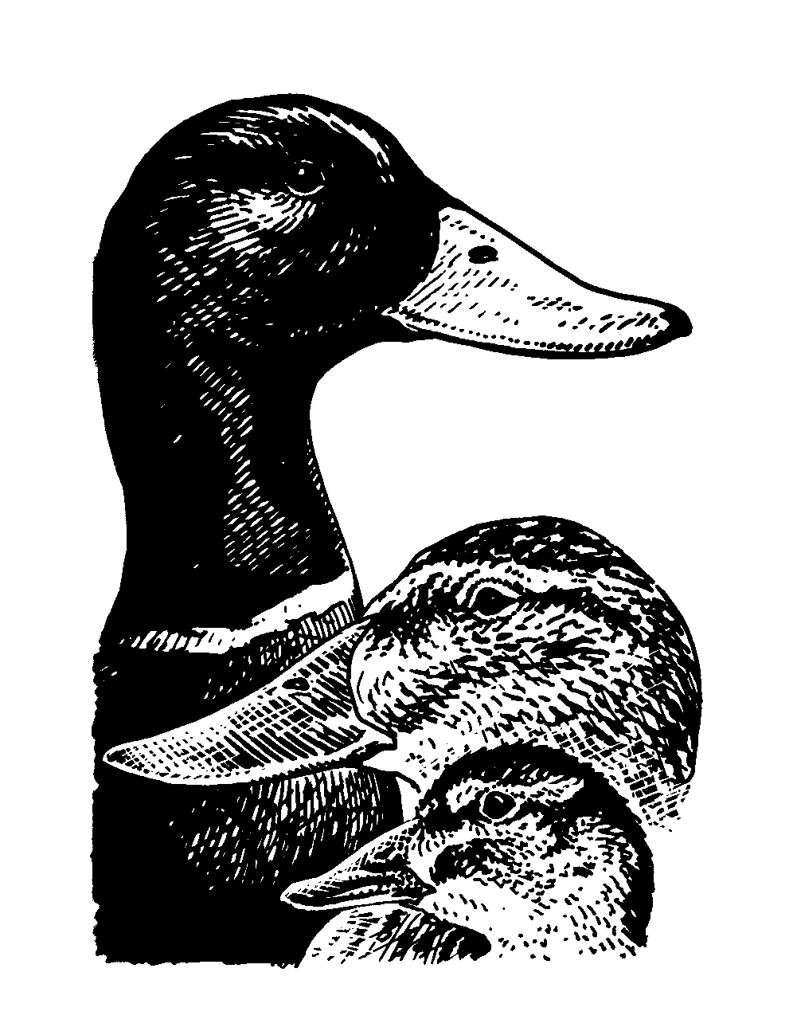

Feeding habitat
- Under trees, on woodland floors and bird tables
- Rivers, shallow water and marshland
- In the air
- Open water
- Soil, hedgerows and gardens
- Heather moorland and lowland fields
- Wet meadows and ploughed fields
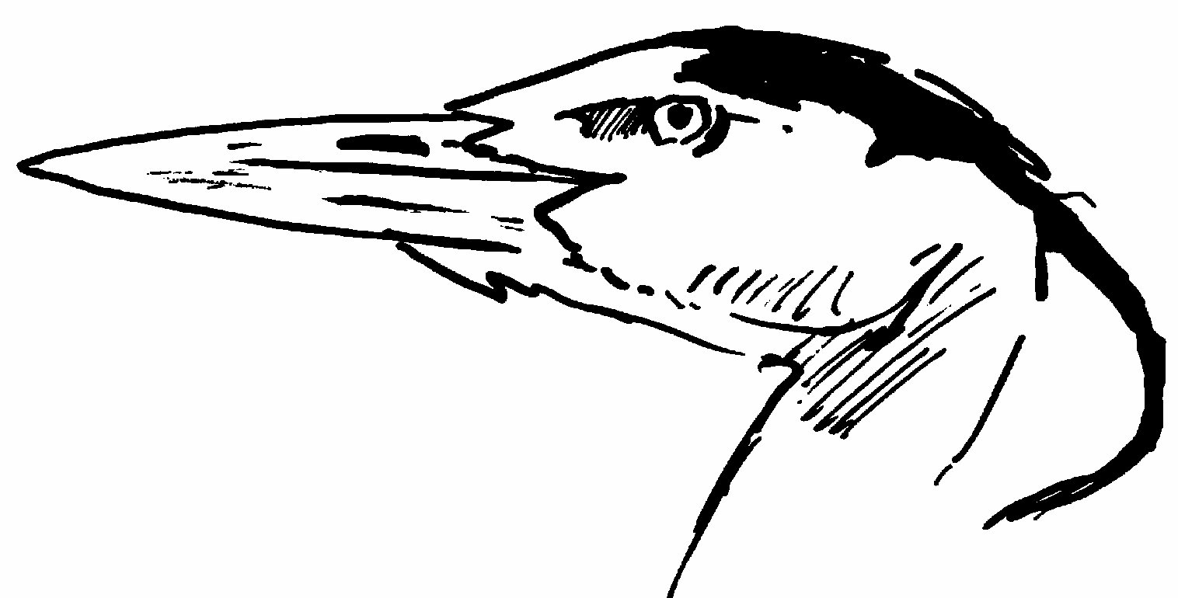
- Moorland and estuaries

Discussion point
In what way are the beaks of birds adapted to the food they eat?

