Watching Birds
Keeping a record of the birds you see
You will need a note book or recording sheet, pencil or pen and a bird identification book or chart. Binoculars or a telescope are useful, but not essential.
All you need to do is watch for birds in the school grounds for a short time each day.
It is best to decide on a place where you can see the birds well and where you can sit quietly so they are not disturbed.
Only count the birds that land, unless they are feeding in your airspace (e.g. swallows, swifts)
You may wish to use the following recording sheet. The recording sheet has the top 15 birds counted in the Big Schools’ Bird Watch and columns to tally numbers of birds seen . There is space at the bottom to add other birds if they appear.
If you prefer, you could make your own recording sheet.
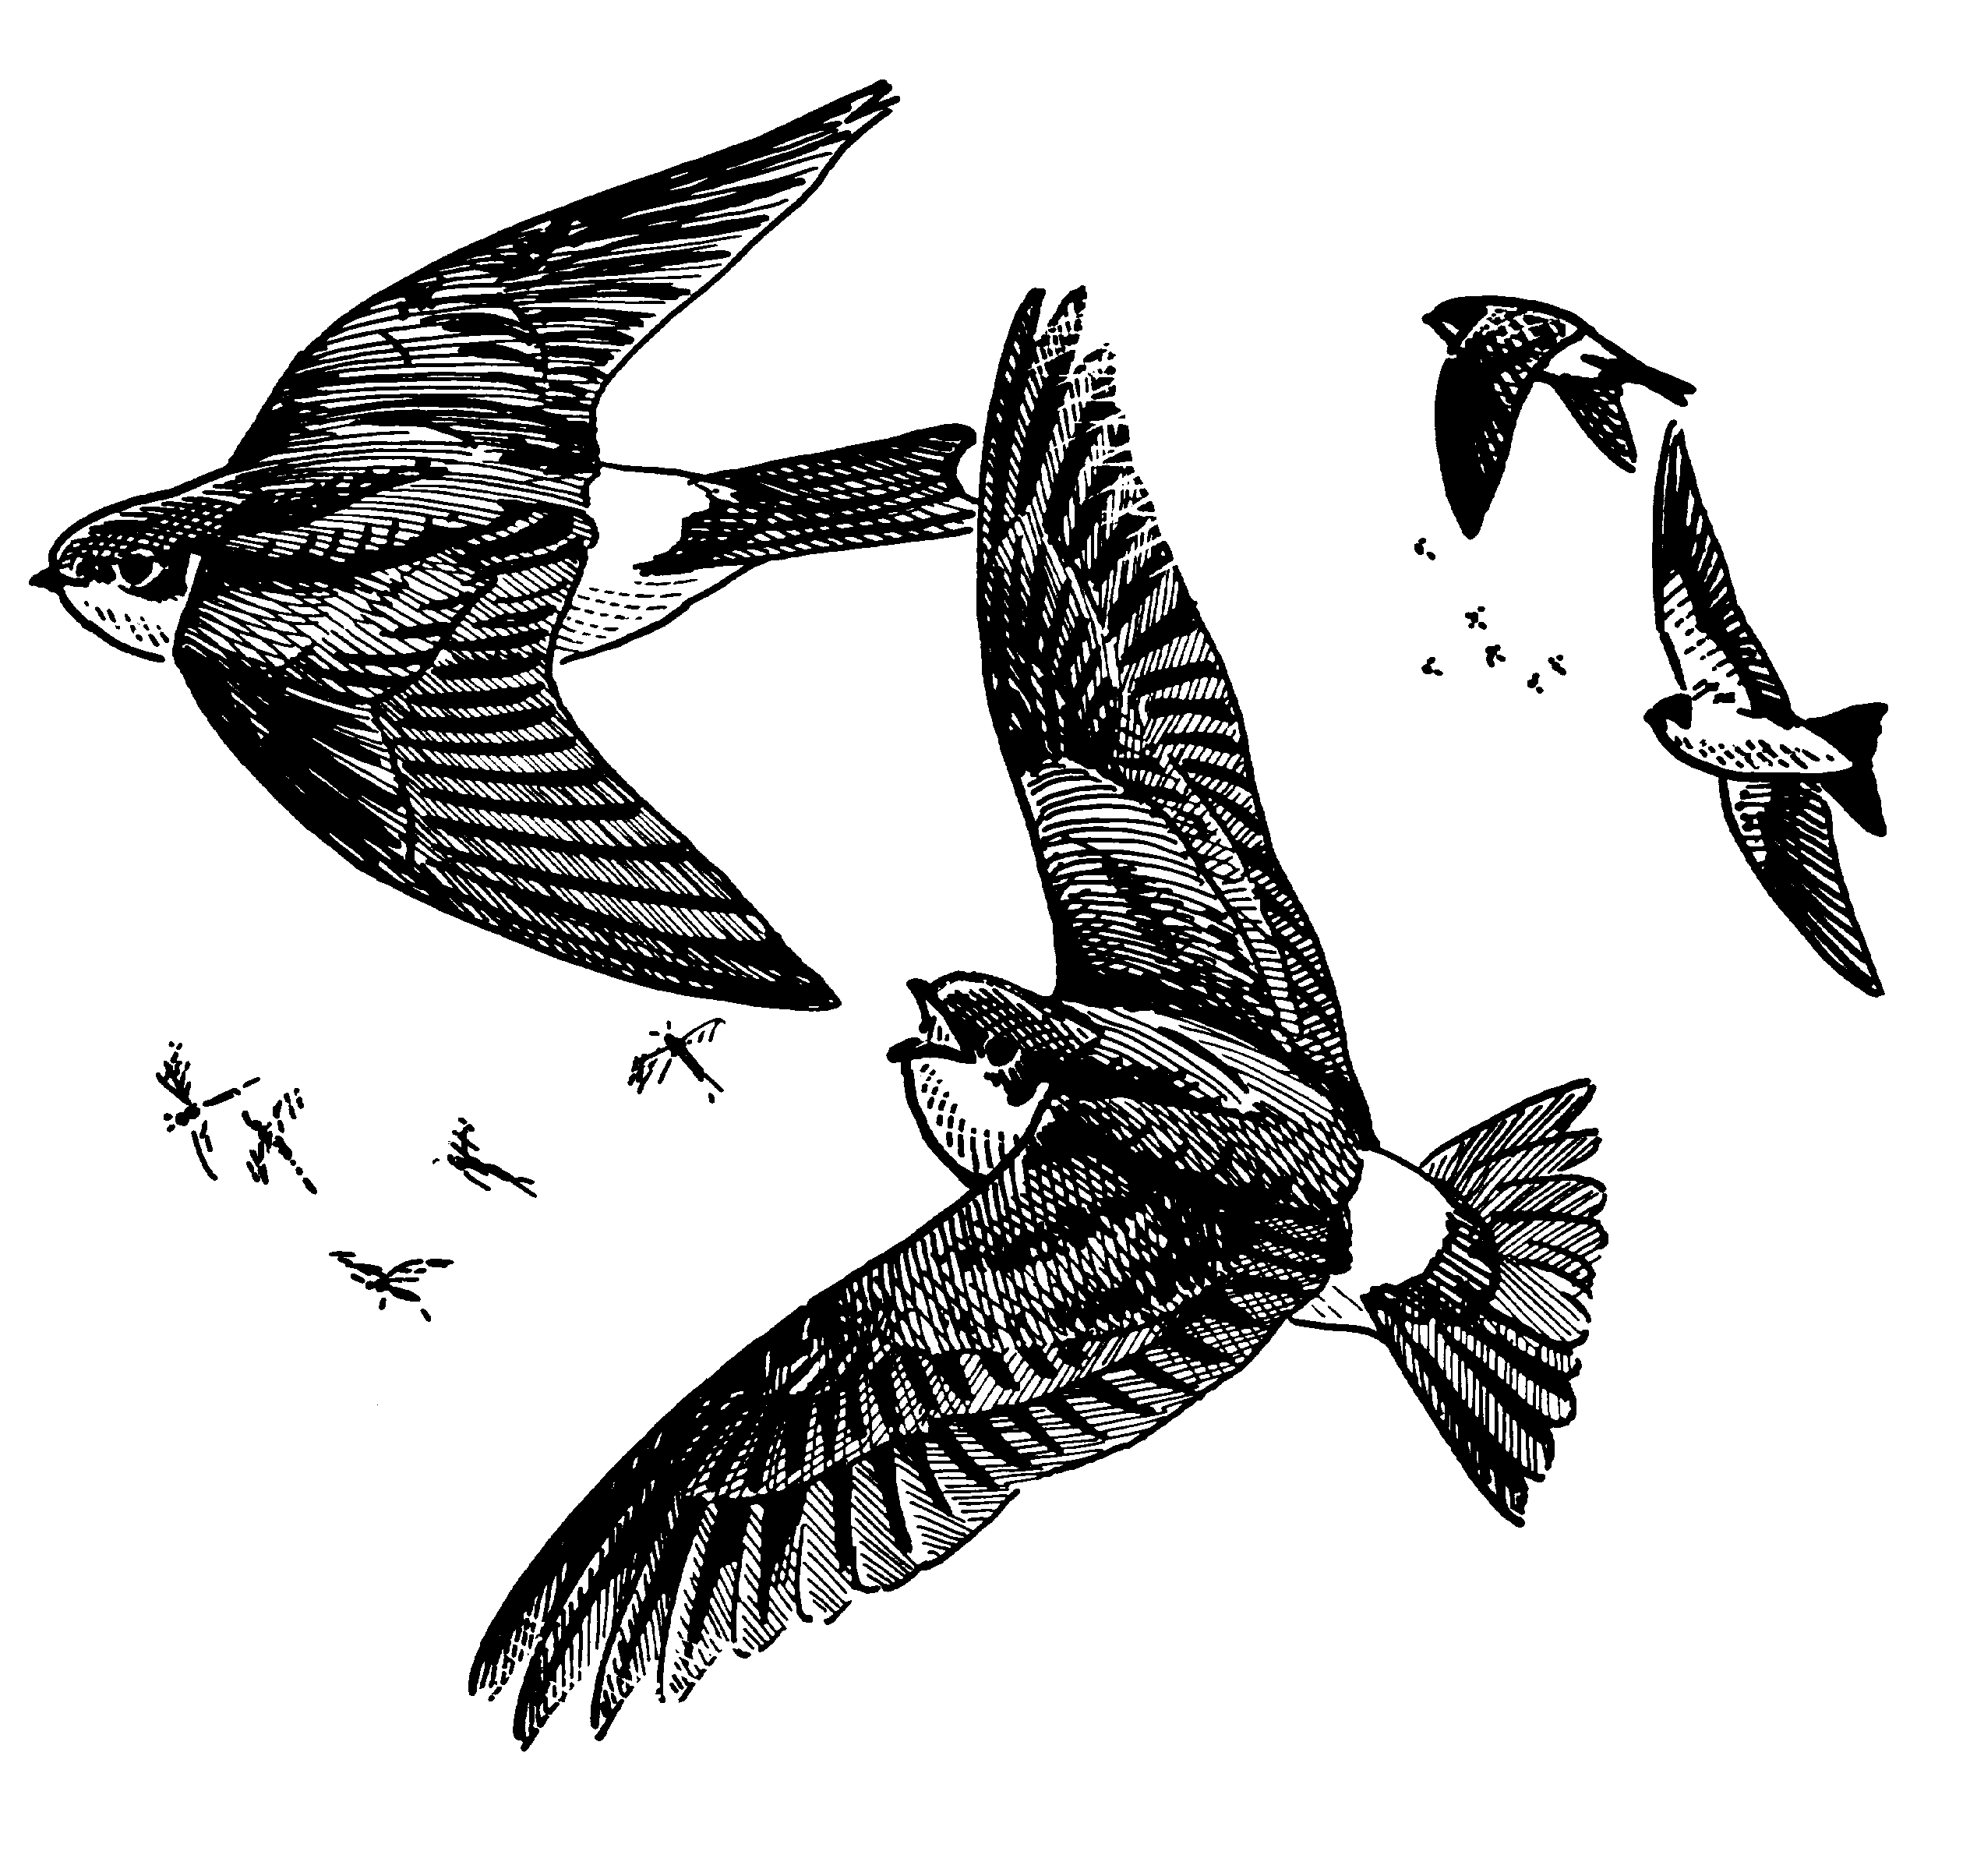
A more detailed record might include what the birds were doing (e.g. feeding, nest building), what they were eating or where they feed (e.g. ground, feeders, air).

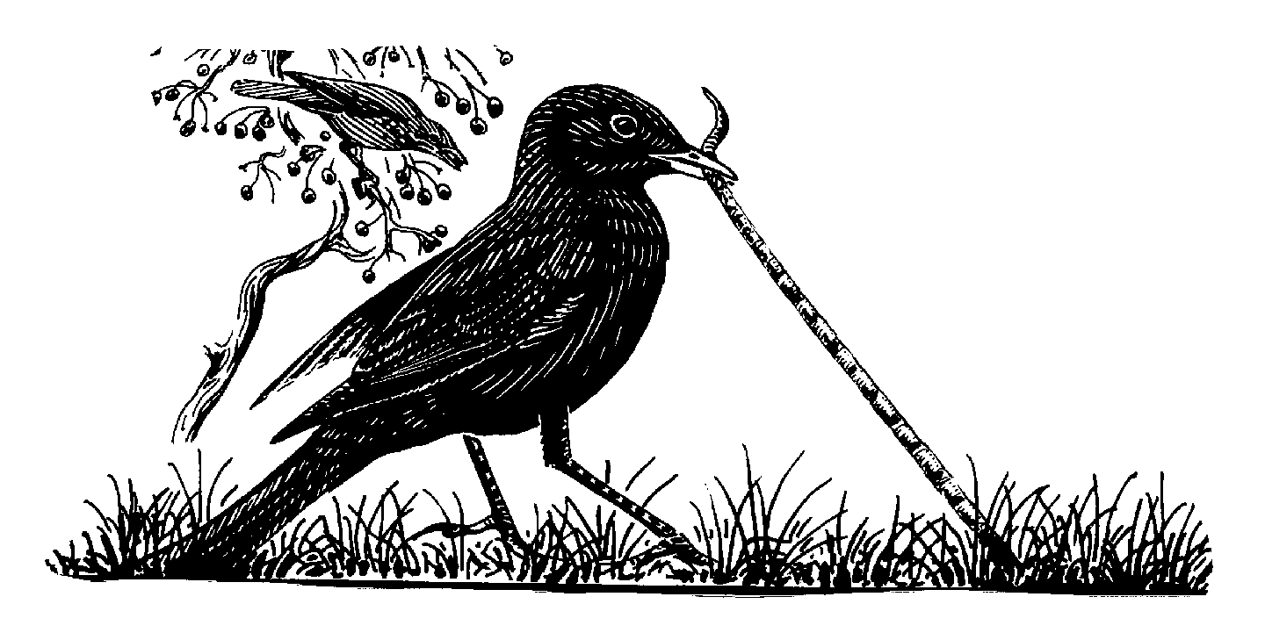
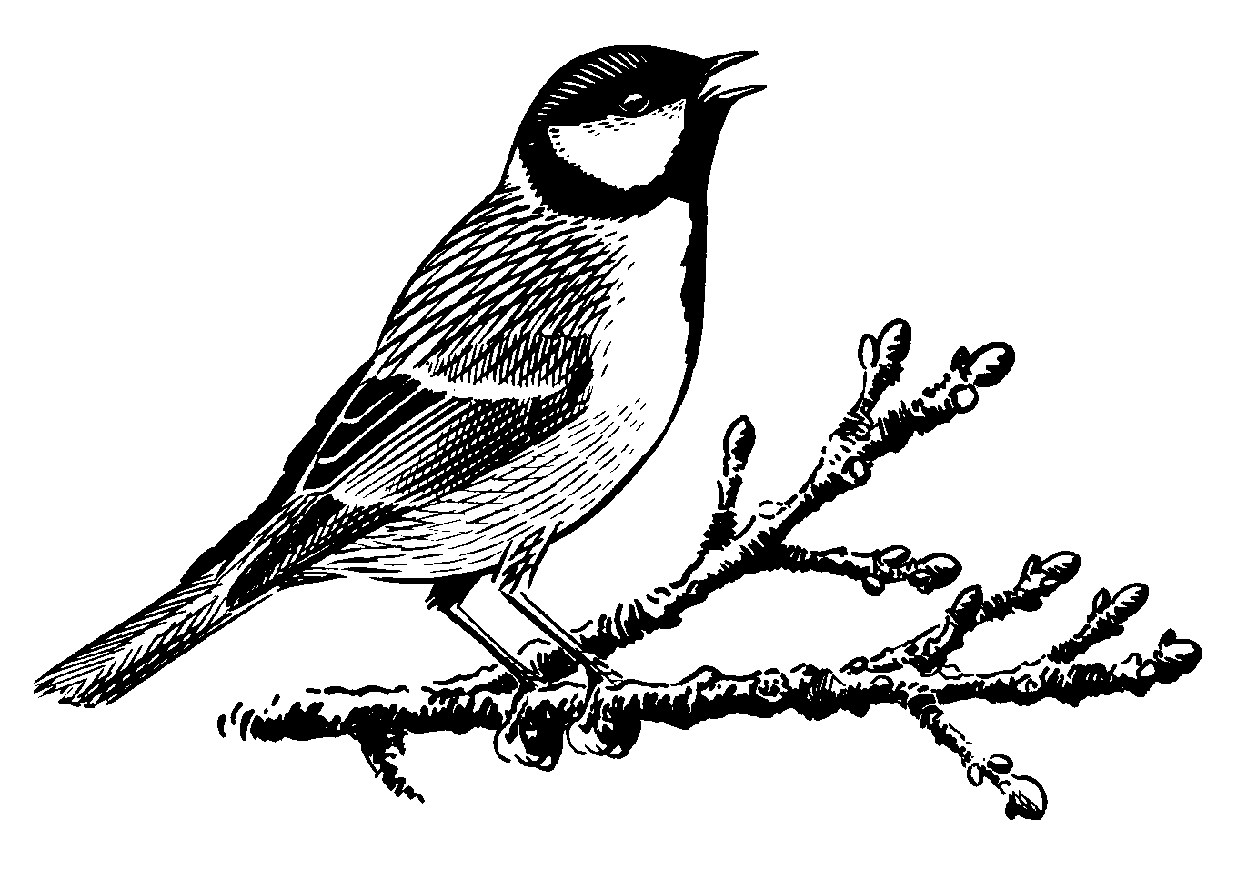

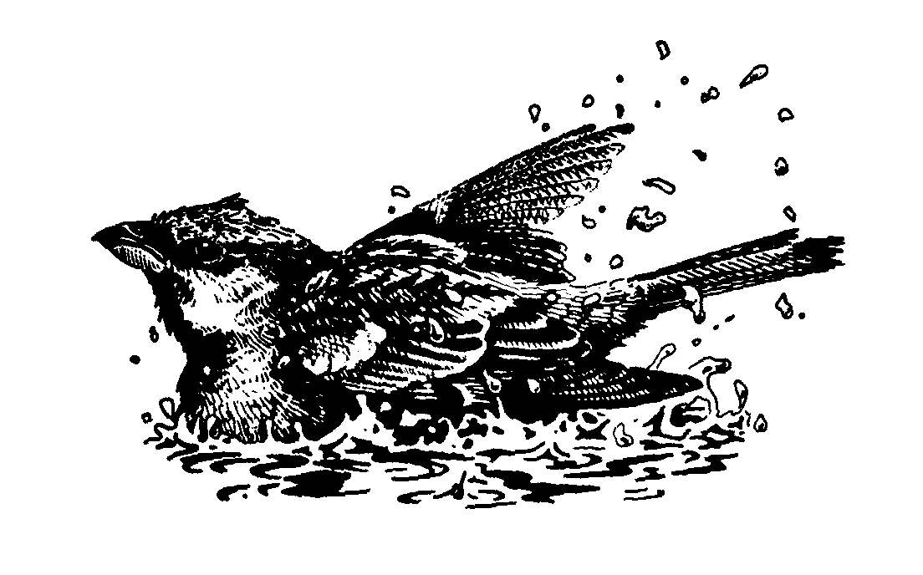

Birds that we have seen

Names:

Date from: to:

Species |  |  |  |  |  |  |  | TOTAL
Robin
Blackbird
Song Thrush
Blue tit
Great tit
Coal tit
Chaffinch
Greenfinch
House Sparrow
Great Spotted Woodpecker
Nuthatch
Dunnock
Pheasant
Magpie
Crow
Rook
Starling
Lapwing
Curlew
Oyster Catcher
Stonechat
Kestrel
Hen Harrier
Red Grouse
Pied Wagtail
Dipper
Species total
Other animals that we have seen:

