Habitats and who lives there

Learning objectives
• To have a simple understanding of the relationship between people and the habitats in the Forest of Bowland.
• To have a basic understanding of what a habitat is and how it is a home to certain plants and animals.
• To appreciate that different animals have different requirements and this affects which habitat they live in.

Background
Ensure that the children know what is meant by the word ‘habitat’. A habitat is the natural home of an animal or plant. That habitat should provide the plant or animal with everything they need in order to survive. It will provide them with the food, water and shelter they need as well as somewhere to breed.
Refer to worksheet ‘Habitats general’

Discuss with the children what different habitats there are in the Forest of Bowland and what plants or animals may live in these habitats.
Refer to Forest of Bowland and RSPB websites

Ensure that the children understand that the Forest of Bowland habitats were created and changed by people. Without people, the Forest of Bowland and Britain would be completed covered in woodland, but since people have been clearing woodland in Britain for thousands of years many of the wild plants and animals here live in other habitats like moorland, and grassland. The children should appreciate that even an area like their school field, if left alone, would eventually revert to woodland. Plants would grow bigger, tree seeds would start to grow and eventually the whole area would begin to look like a woodland. Other areas are managed by people to ensure that this does not happen for example the Forest of Bowland. Ask the children to think of reasons why we might want grassland rather than woodland e.g. to run about in (playing field or park), to feed animals (field), to conserve wildflowers (meadow).

Activity
Introduce the habitat characters:

• Tom – the tawny owl (woodland)
• Fred – the common frog (water)
• Graham - the grasshopper (grassland)
• Stan – the spider (walls)
• Lucy – the ladybird (rose bed)
• Jenny - the wren (hedgerow)

Look at the characters and discuss what animal they are. Cut up the sheet so the picture is separate from the description. Read the character descriptions and try and match them to the characters. Talk about the commentary from each of these characters and discuss what each character would need in their habitat in order to survive. Ask questions. Would Nigel be able to live where Stan lives? Why not? Would Tom be able to live where Lucy lives? Why not?

These characters can then be used as the basis for story writing or other creative writing based around animals and their habitats.

Tom Tawny Owl

My favourite habitat to live in is a woodland, although I do sometimes live in big parks or large gardens. A habitat such as this is a good hunting ground for me. I like to eat mice, voles and shrews and these animals live mainly in wooded areas. Sometimes I eat small birds or even a frog or a tasty large beetle!

I have very sensitive hearing and this helps me to find the animals that I eat. These animals are called my ‘prey’. I also have large talons to grip onto my prey when I have caught it. I hunt at night so you won’t see me during the day! Have you heard me call ‘kewick’ or ‘hoohoo-oo-oo’?

I need a hole in a large tree to build my nest. Sometimes I like to use a special nest box. In March I will lay my eggs. My babies live in the tree hole until they are old enough to come out into the tree. Here they will take their first flight and go hunting for small animals to eat.
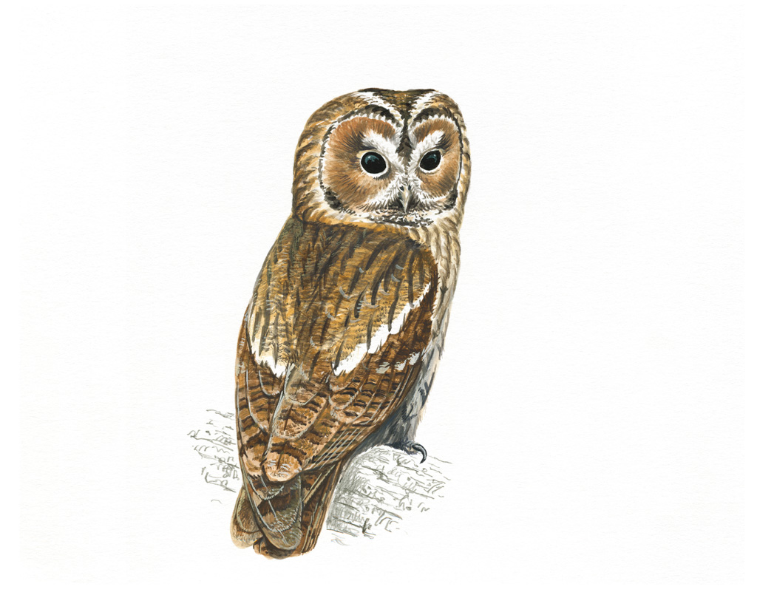
Copyright Mike Langman (rspb-images.com)

Fred Frog

I need a habitat that has somewhere for me to hide during the day. It needs to be cool and damp there because I like to keep my skin wet. During the night, I will come out to feed. I eat worms, slugs and other small animals.

I need ponds or small pools in the habitat that I live in because I need to lay my eggs in water. I lay my eggs onto a leaf under the water and roll the leaf around the egg. It hatches into a special kind of tadpole. My tadpoles grow front legs, then back legs and like to hide in the pond weed or other plants.

Before long, the tadpoles look like a little version of me! They don’t stay in the water for long. Soon they are out looking for a cool damp place to hide during the day.
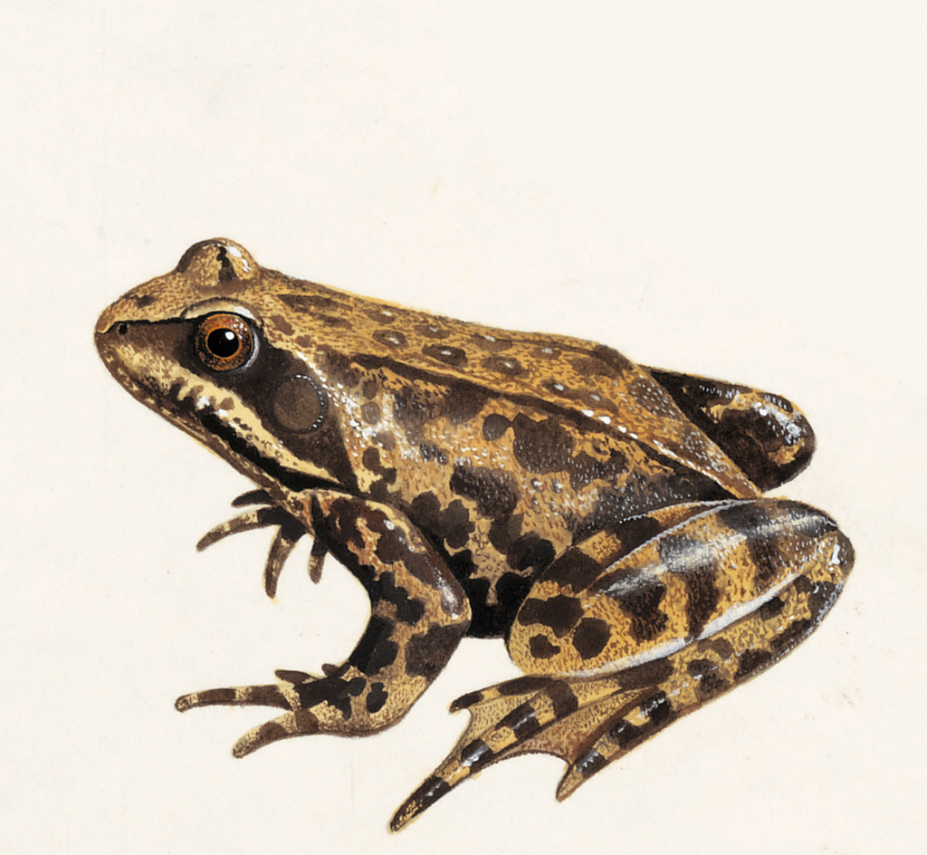
Copyright Chris Shields (rspb-images.com)

Graham Grasshopper

I need a habitat where there is a lot of long grass as this is what I eat. I also like the long strands to sit on and sing my chirping song. I make this chirping sound by rubbing my legs together.

A habitat with long grass protects me from other animals and birds that might want to eat me. I hide well in the grass as my body is the same colour. I can fly, but not very well. You may see me jump because I have long legs. I can leap between one piece of grass and another.

I lay my eggs in the soil and they stay there all winter. In the spring they hatch. My babies look like me, except they have no wings. They shed their skin as they grow and after about four months, they shed their skin for the last time and have new wings underneath!
Copyright Chris Shields (rspb-images.com)
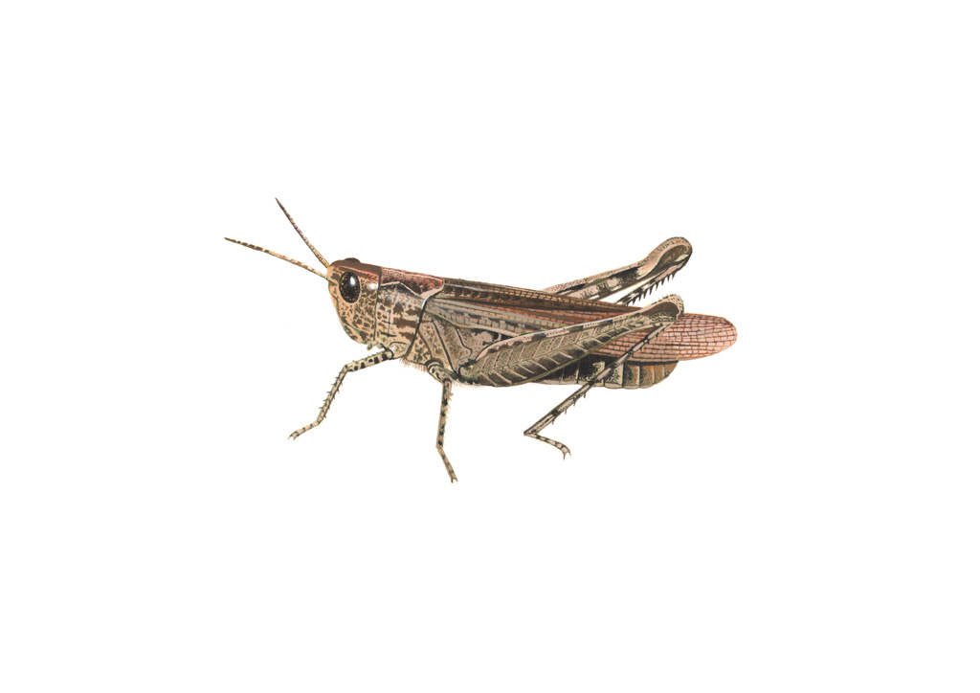

Jenny Wren

I am a shy bird, who likes to hide in the undergrowth, so I need a habitat that has lots of small trees and bushes for me to shelter in. I am brown and speckled so I can blend in with the branches and hide from other birds and animals that may eat me.

I need a habitat that has lots of insects, spiders and small seeds for me to eat. I also need a quiet, well protected place for me to build my nest. Tree trunks, ivy covered walls or thick bushes are best. I need leaves, moss and grass in my habitat to build this nest.

I am very tiny, so get cold easily. In the winter, I need somewhere to go to keep warm. Many of us die in cold winters because we cannot find enough food and we get too cold.
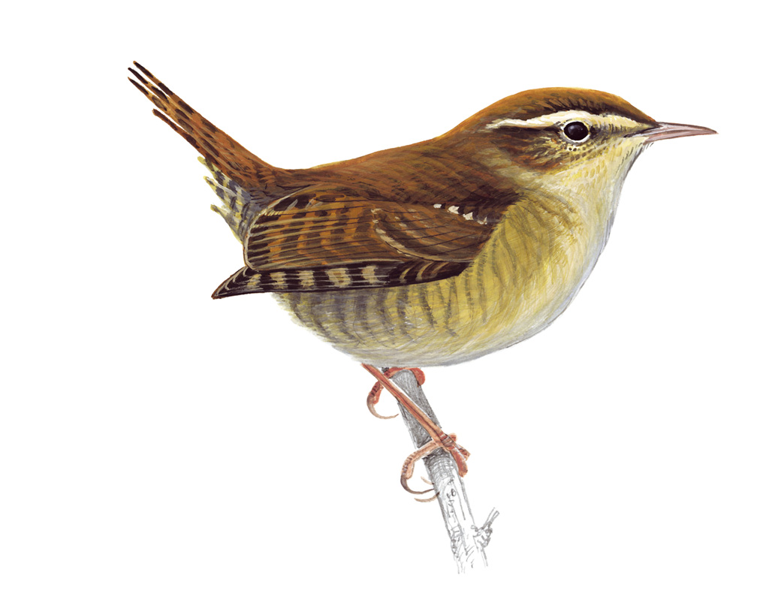
Copyright Mike Langman (rspb-images.com)

Stan Spider

I can live in lots of different habitats as long as there is somewhere for me to spin my web and there are insects around for me to eat! I like living where there is somewhere for me to spread out my web and a hole for me to hide in.

I have to watch out though. Lots of birds like to eat me, so I have to camouflage well and keep a look out!

You can find me spinning my web on buildings or bushes. I especially like the corners of window frames or I sometimes make my web across a door frame. My web is sticky, so any insects flying into it, by accident, get stuck! I can then go and eat them for my dinner
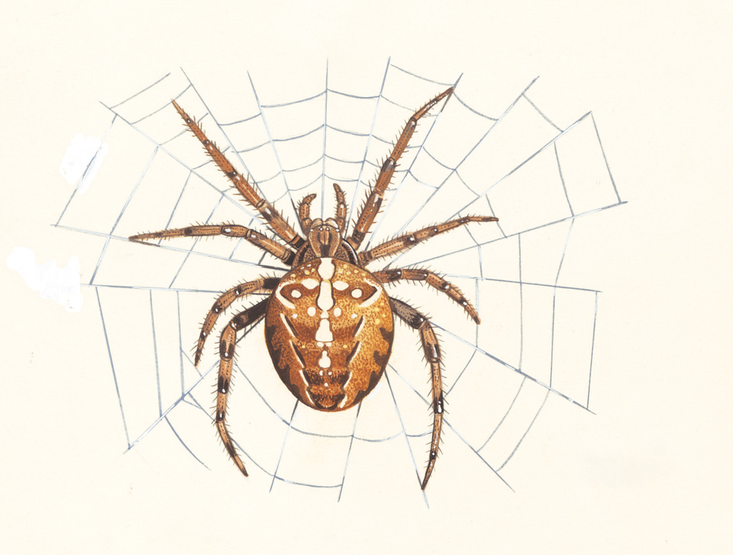
Copyright Chris Shields (rspb-images.com)

Lucy Ladybird

I am often found in a garden habitat because my favourite food likes to live on roses. I eat aphids, or you might know them as greenfly. I lay my eggs on plants and my young, which are called larvae, can eat hundreds of aphids before they turn into an adult. This is why gardeners like to have us around!

I am a kind of beetle and I can fly. My wings are hidden under my brightly coloured wing case. I am brightly coloured to warn other animals that I am not good to eat. I taste very bitter.

I will live in a variety of habitats as long as there are plants and aphids around. In the winter we need our habitat to have a place where we can hide and hibernate. This could be a crack in a piece of wood or a under the bark of a tree.
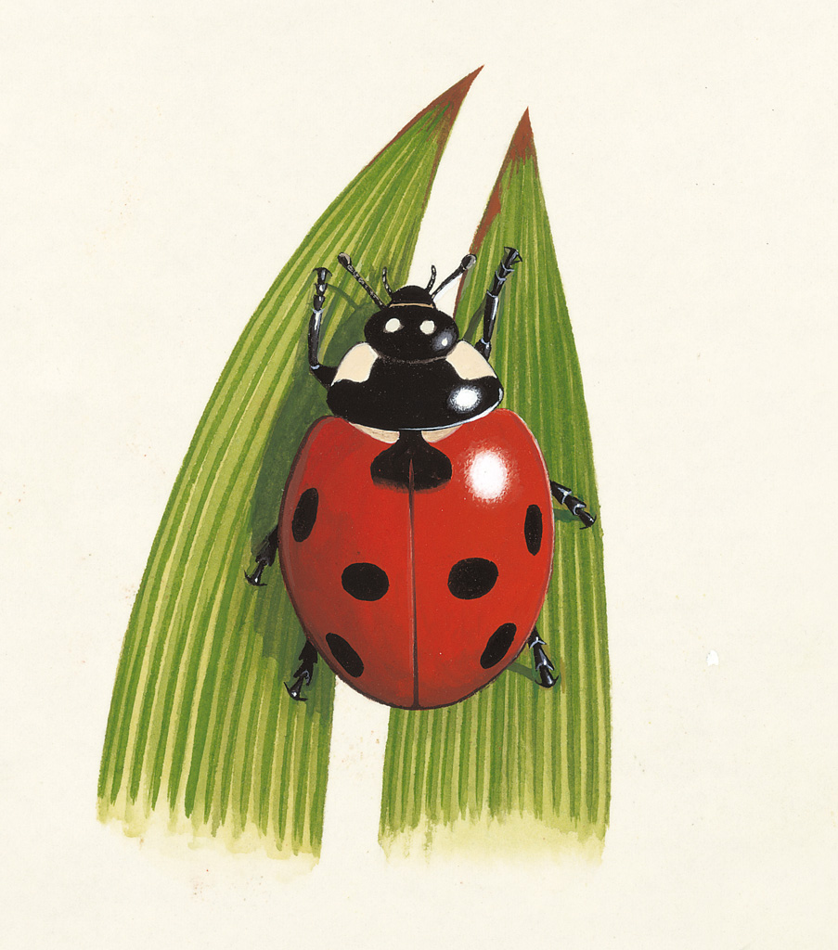
Copyright Chris Shields (rspb-images.com)

