Garden Birds

Birds like to eat food found in the garden. They find seeds, berries and insects to eat.
We can put food, like peanuts and birdseed, in our gardens for the birds to eat.
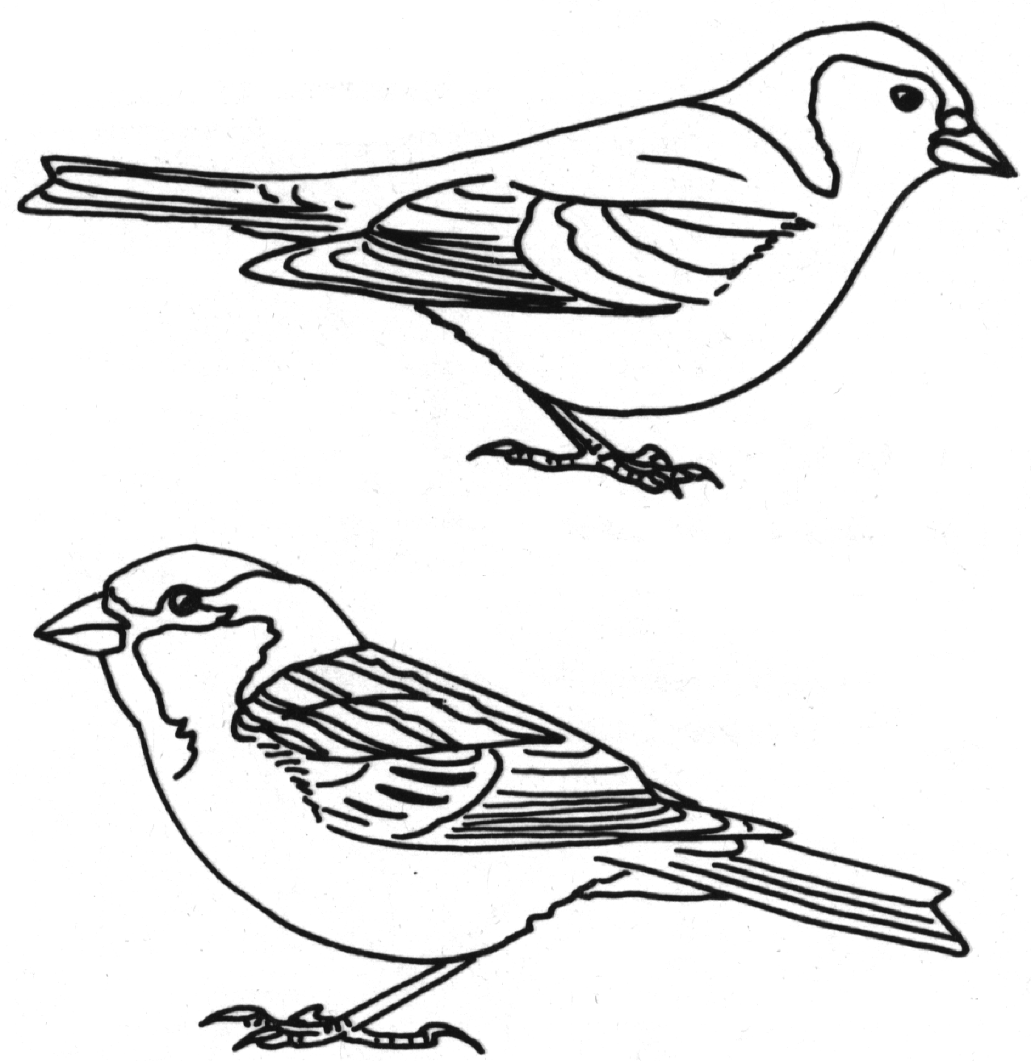
Colour in the pictures of these five birds that we could see in our gardens.

The two birds on the right are;
- male Chaffinch, at the top
- House Sparrow at the bottom.

The three birds at the below are;
- Robin, at the top
- Wren, bottom left
- Blue tit, bottom right

