Blue tits in the garden
Blue tits like to eat the peanuts put on the bird table in the garden.
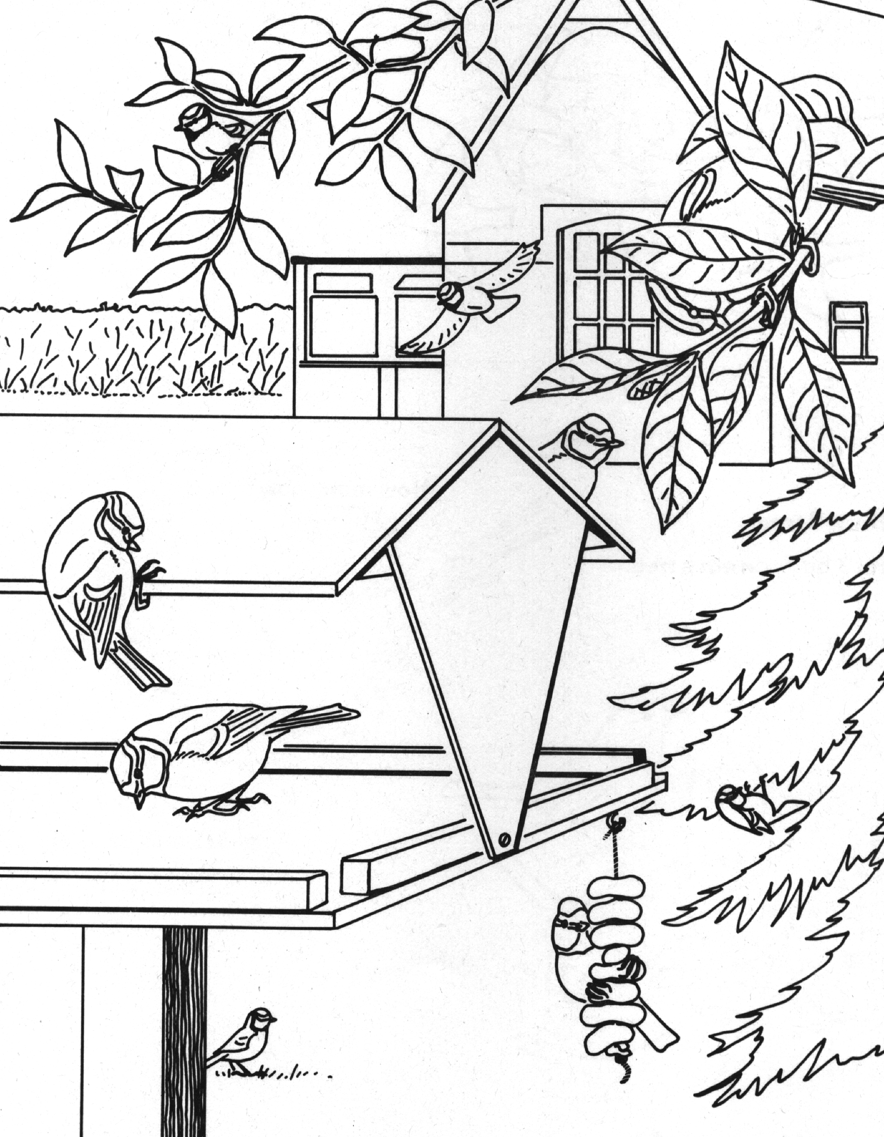
Colour the picture.

Discussion Point
How does it help the birds when we put food in the garden for them?

