Find Your Flock

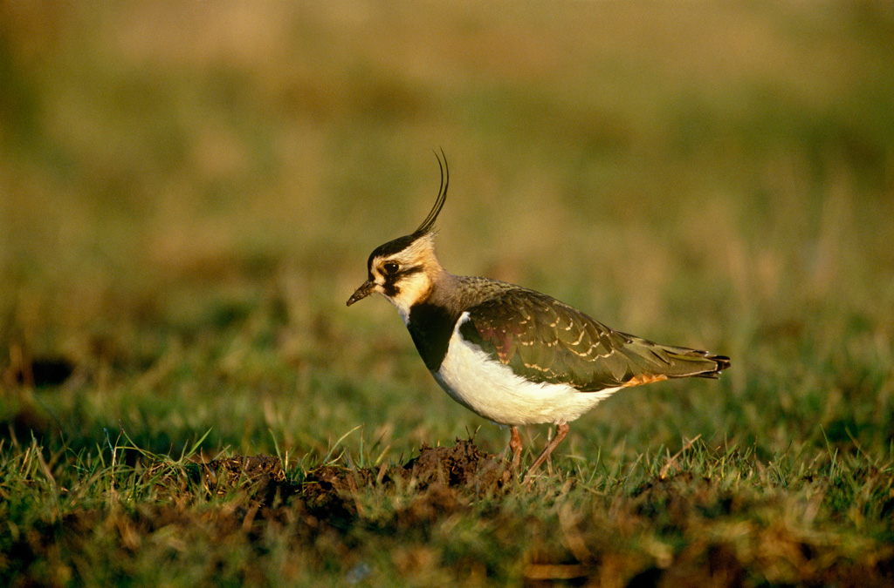
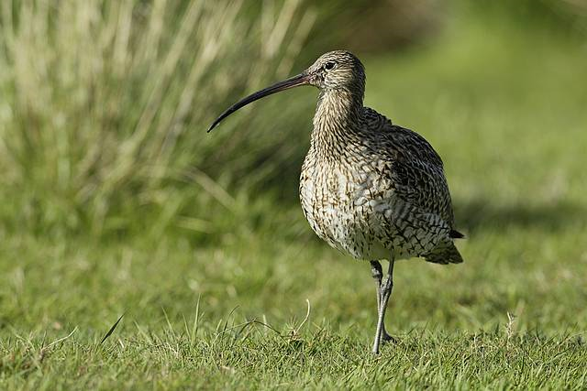
Lapwing – ‘tew-wit’

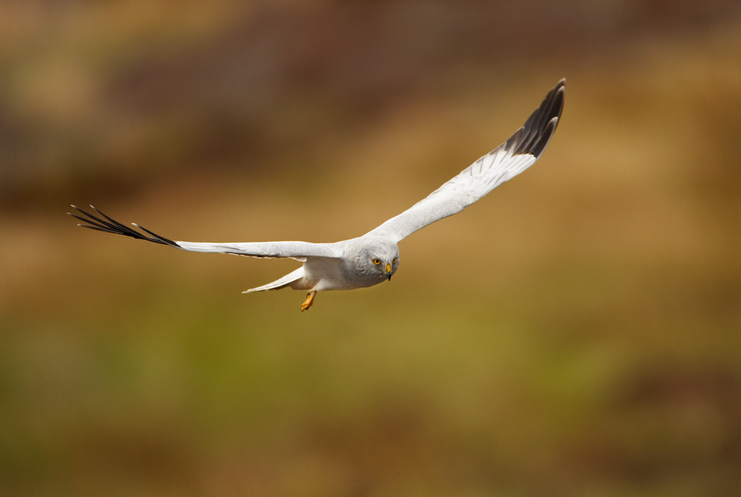
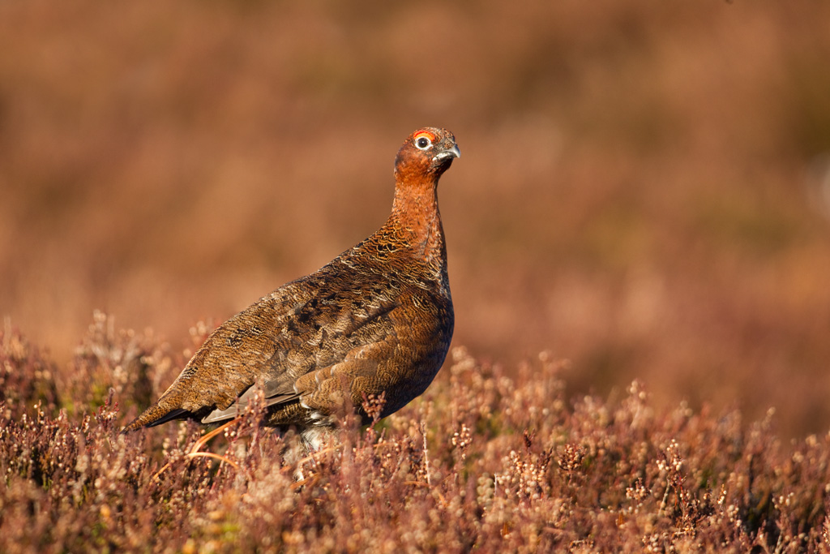
Hen harrier - ‘chik-ik-ik-ik’
Red grouse —’gback-gback’
Lapwing – ‘tew-wit’
Hen harrier - ‘chik-ik-ik-ik’
Lapwing – ‘tew-wit’
Red grouse —’gback-gback’
Red grouse —’gback-gback’
Curlew – ‘courlee’
Curlew – ‘courlee’

